Département de Génie Informatique et Communication

Department of Information and Communication Engineering

Topic : TP13

Subject : Internet Programming

Teacher : Mr. Hok Tin

Name : YORNG TONGHY

ID : e20191313

Group : I4-GIC-C

Year : 2022-2023

Table of Contents

❖ Home Page 3

Admin Dashboard Login Page 3

Admin Dashboard 4

- Category 4

- Add New Category 4

- Edit Category 5

- Delete Category 6

❖ Sub Category 7

- Add new sub category 8

- After add new sub category 8

- Delete sub category 10

❖ Product 11

- Create New Product 11

- Click Product to view product detail 12

- Delete Product 13

- Home view after do crud on category, subcategory and product 14

GitHub Link: <https://github.com/yorng-tonghy/TP13_Internet_Programming>

Small Project Recap

# Home Page

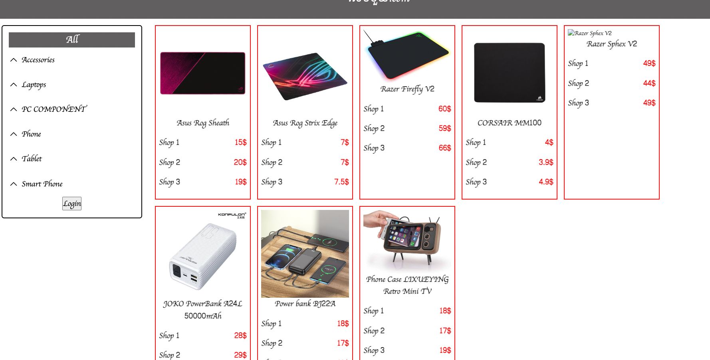

# Admin Dashboard Login Page

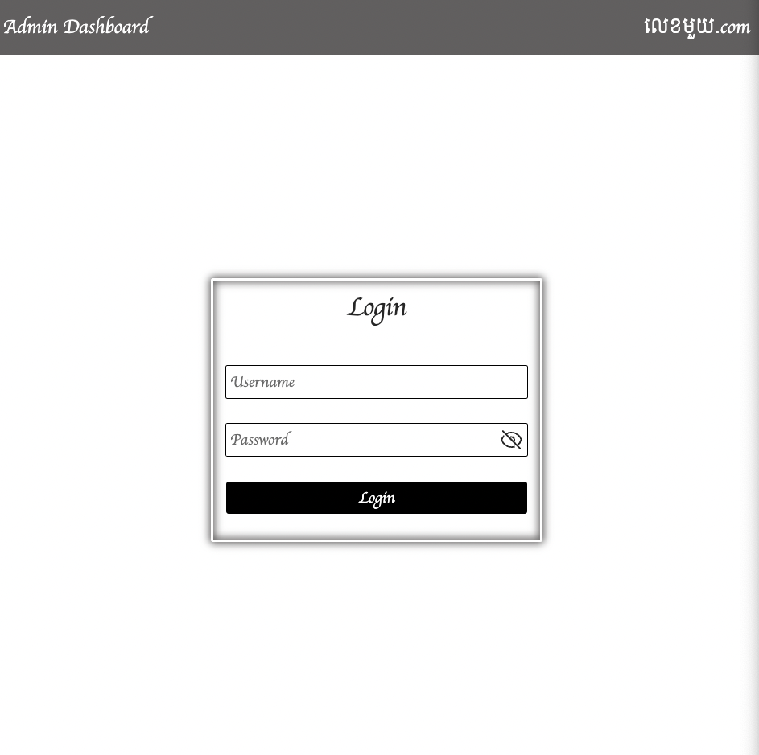

# Admin Dashboard

## Category

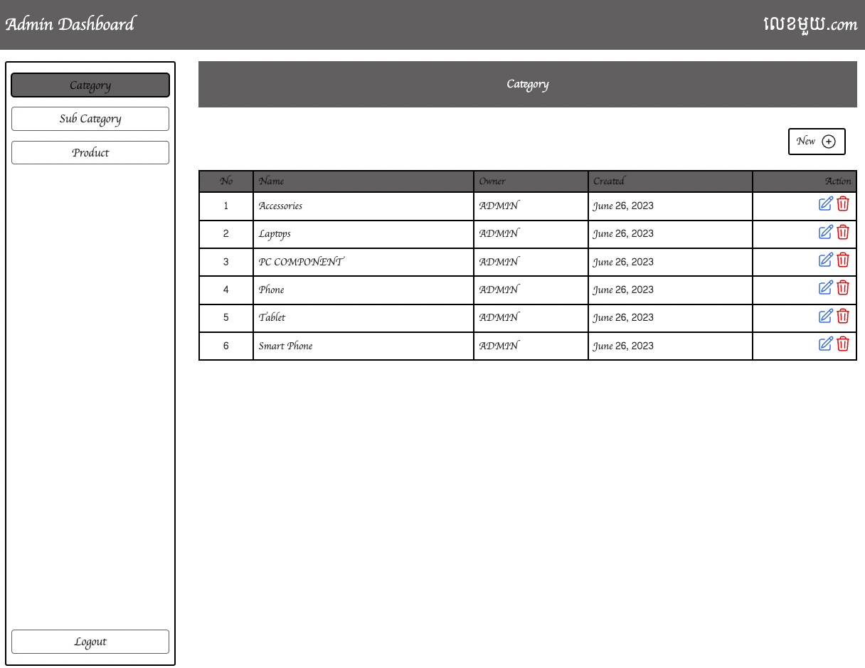

## Add New Category

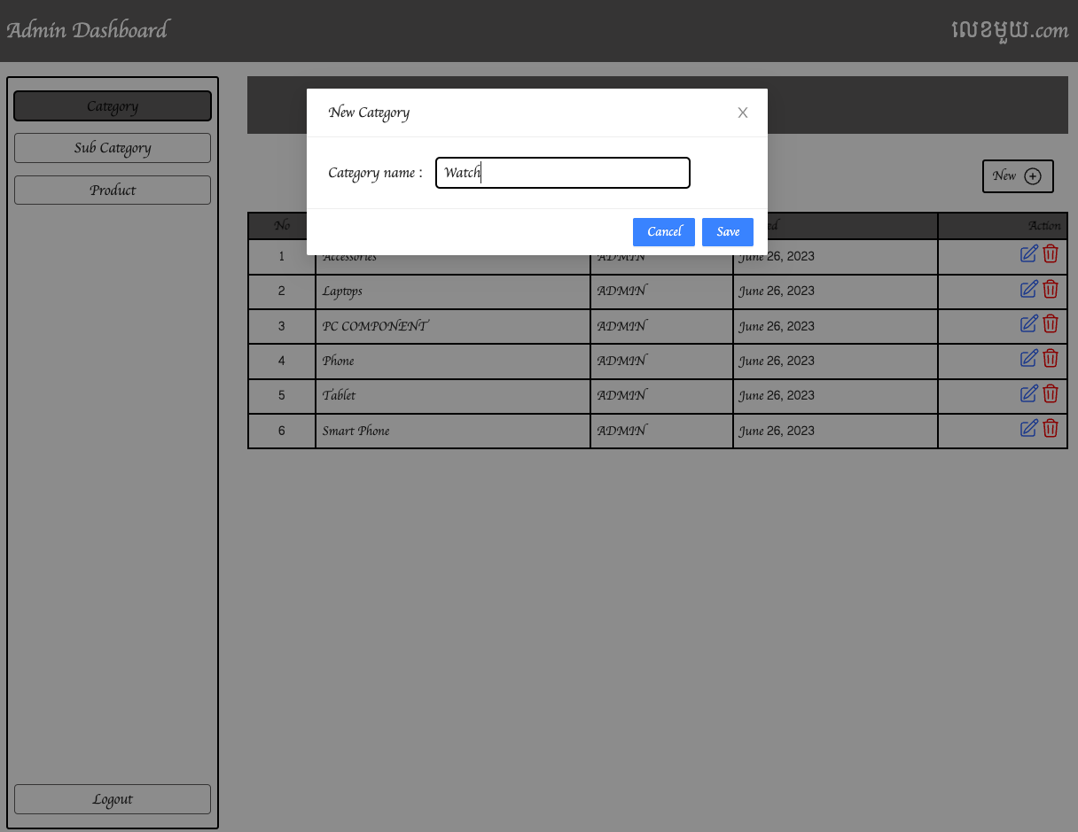

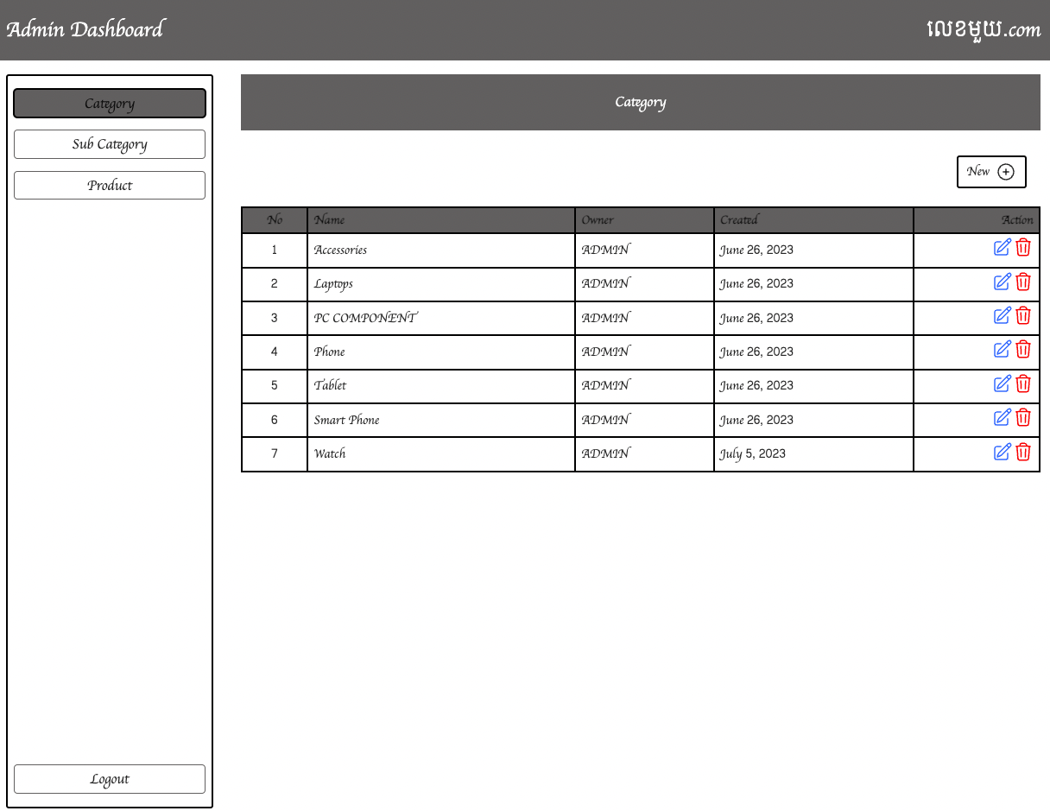

## Edit Category

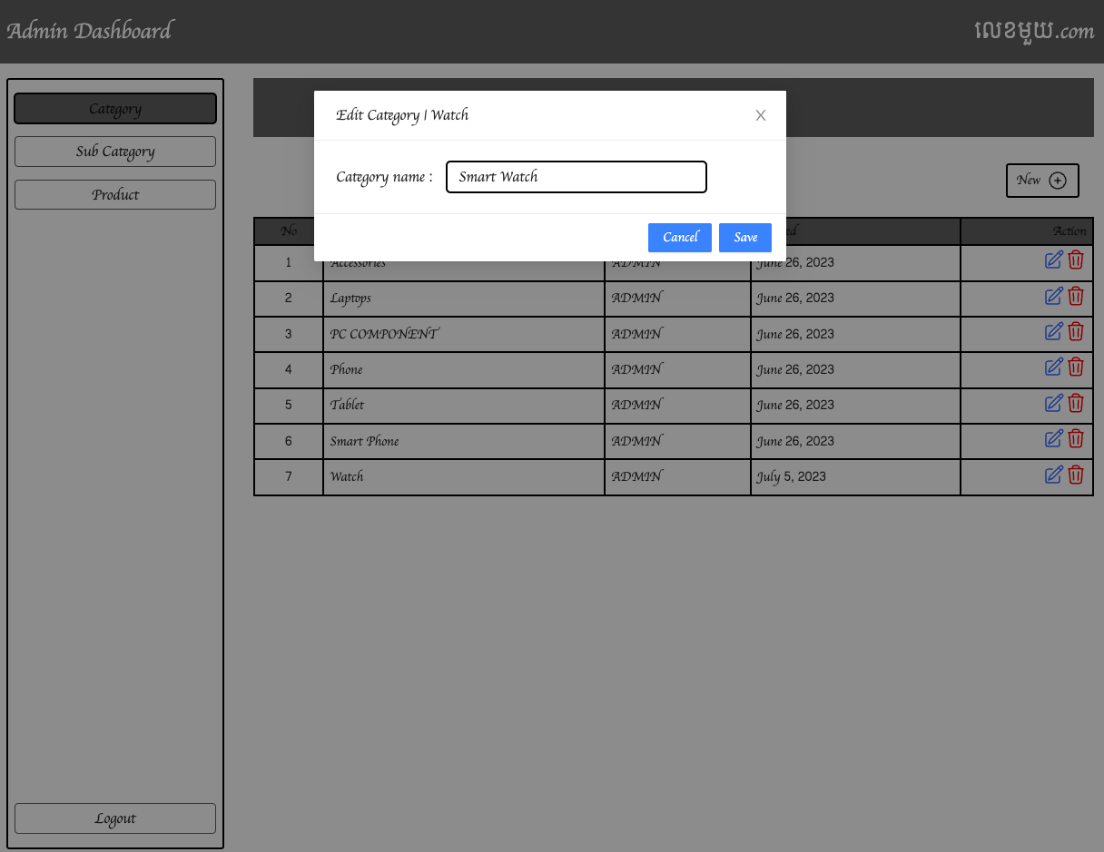

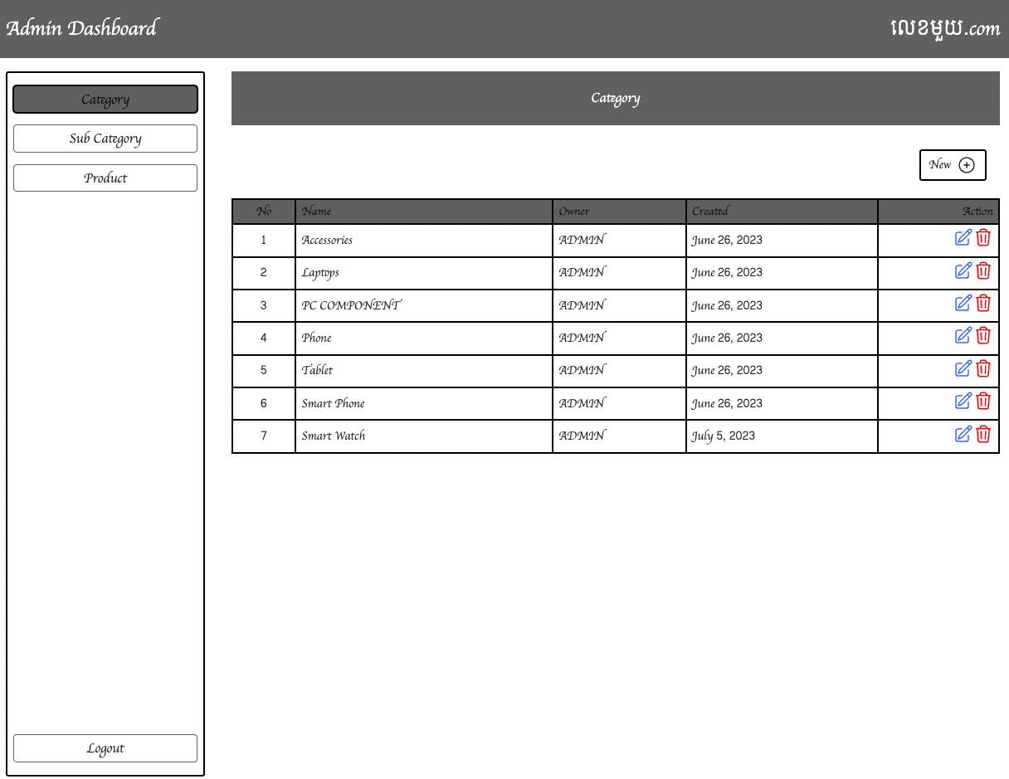

## Delete Category

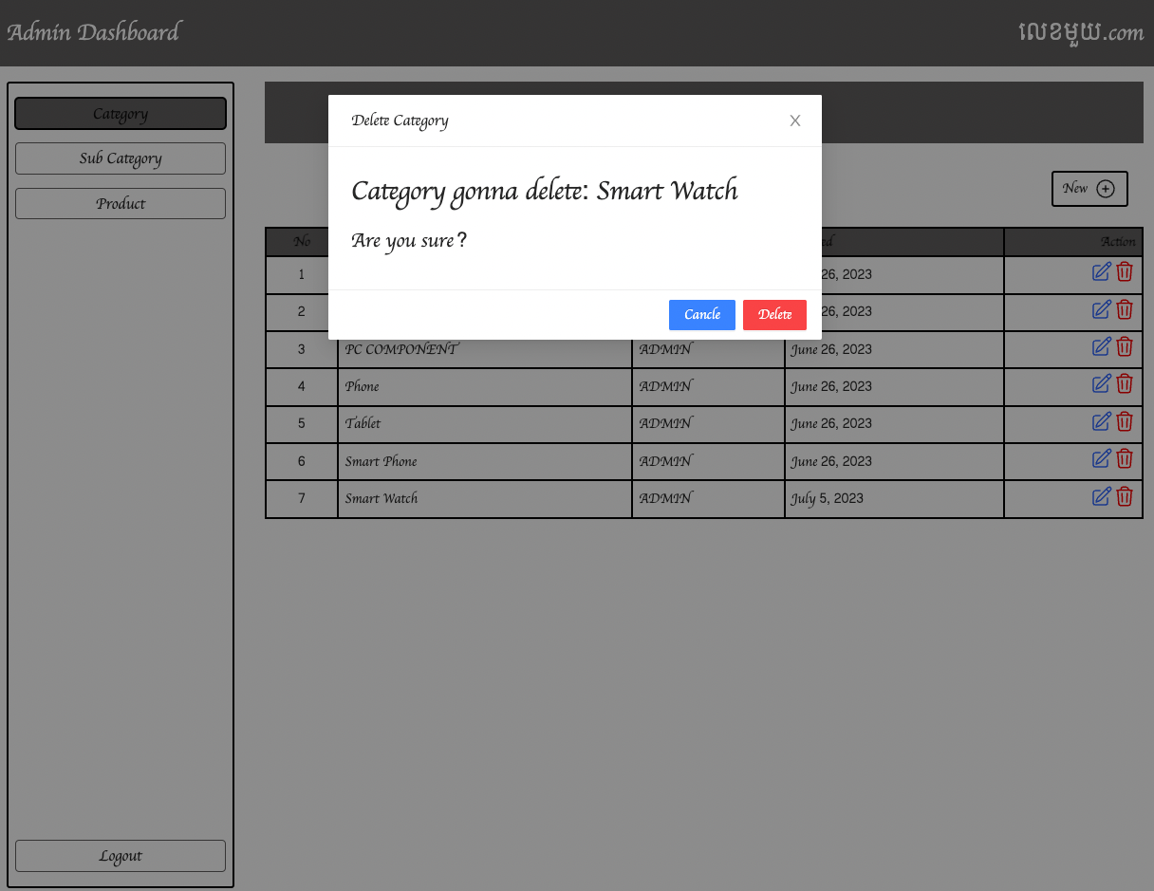



# Sub Category

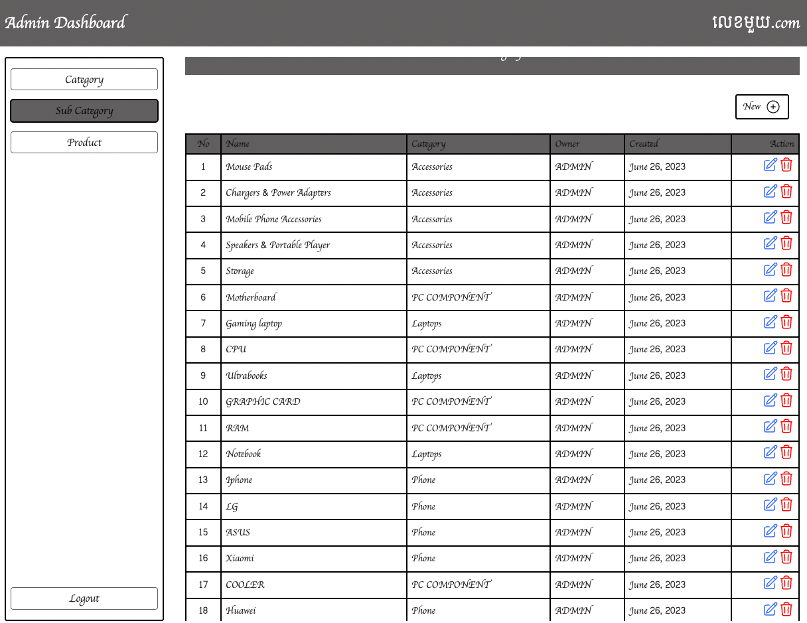

## Add new sub category

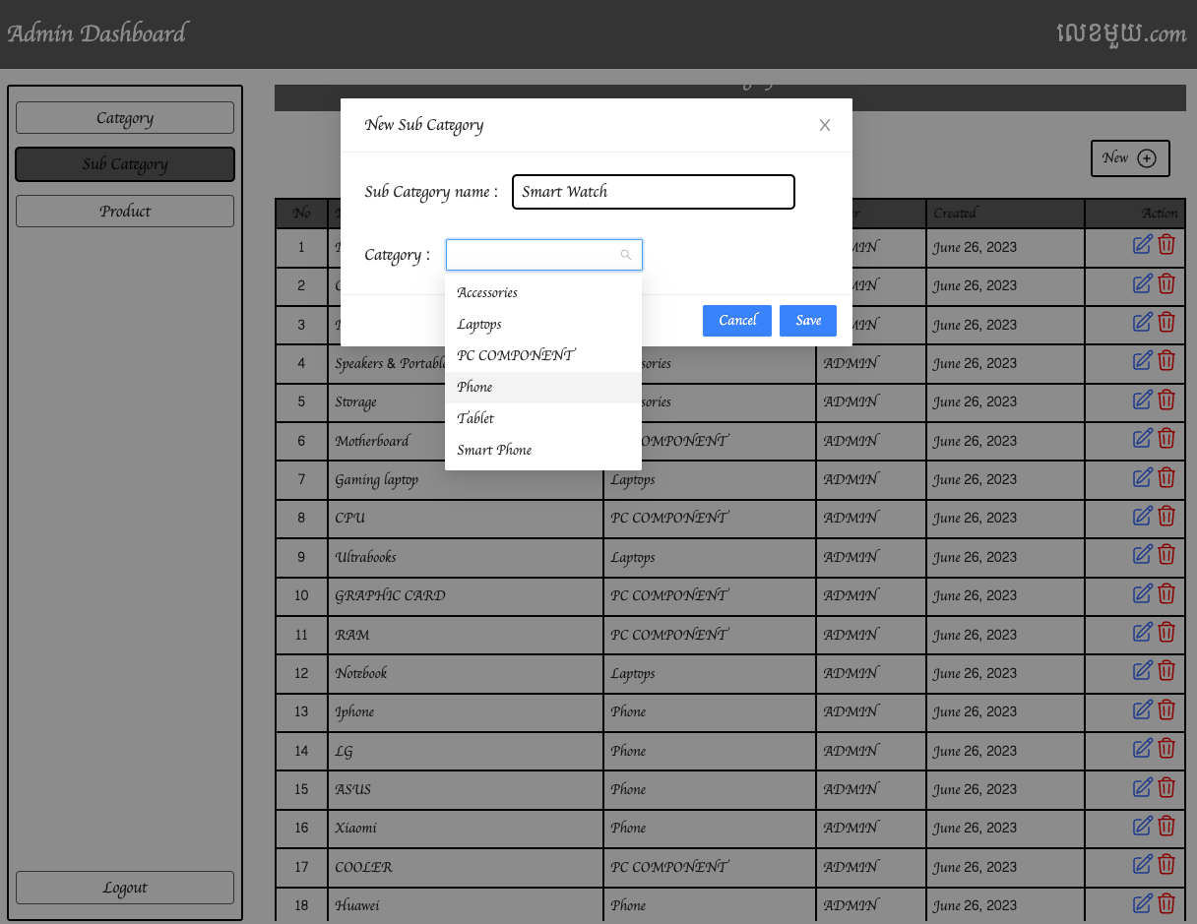

## After add new sub category

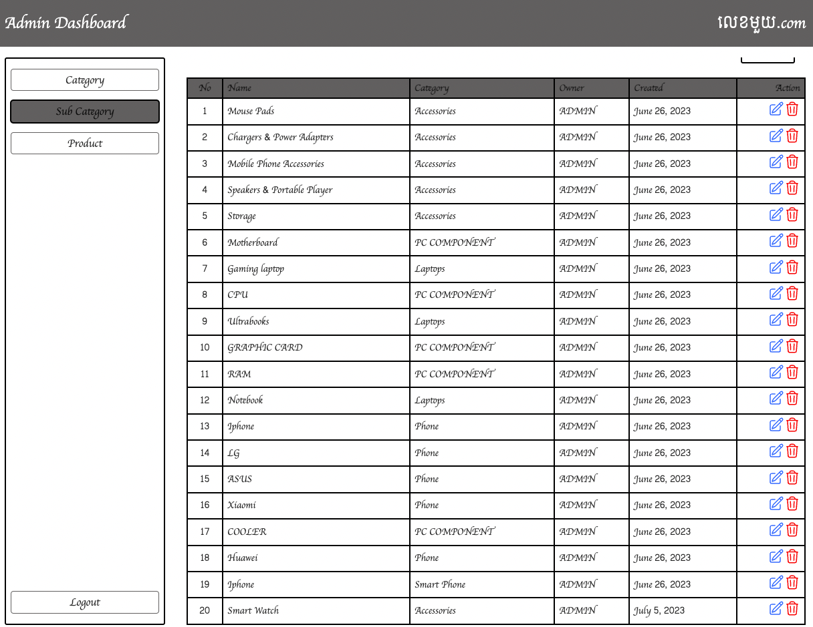

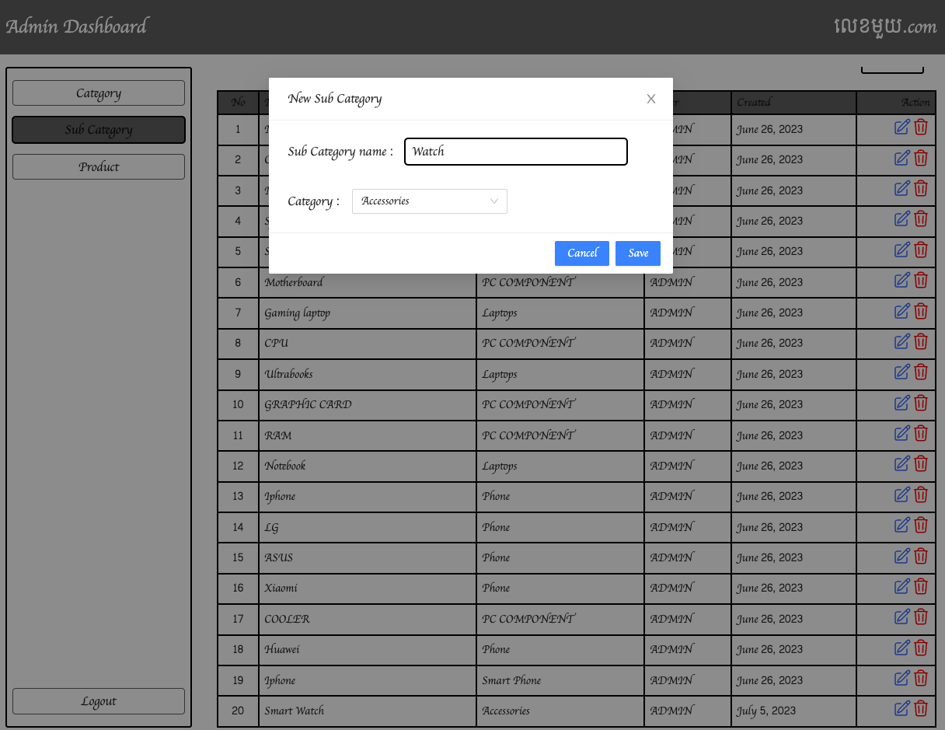

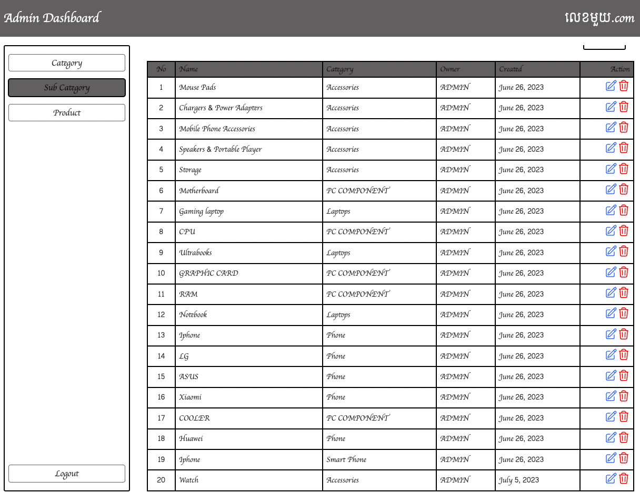

## Delete sub category

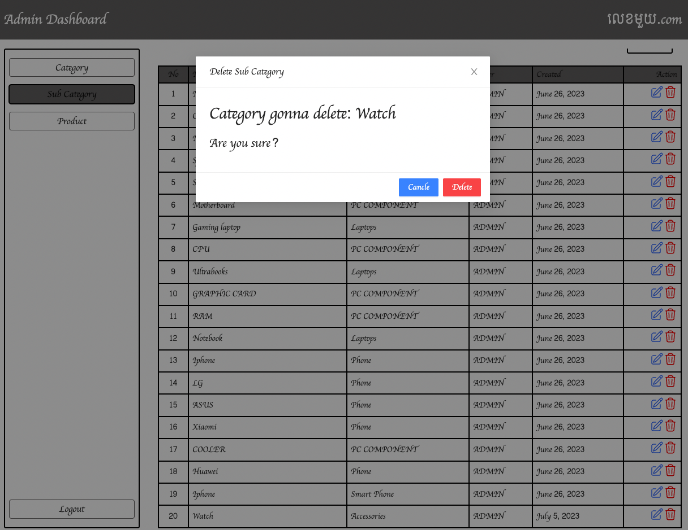

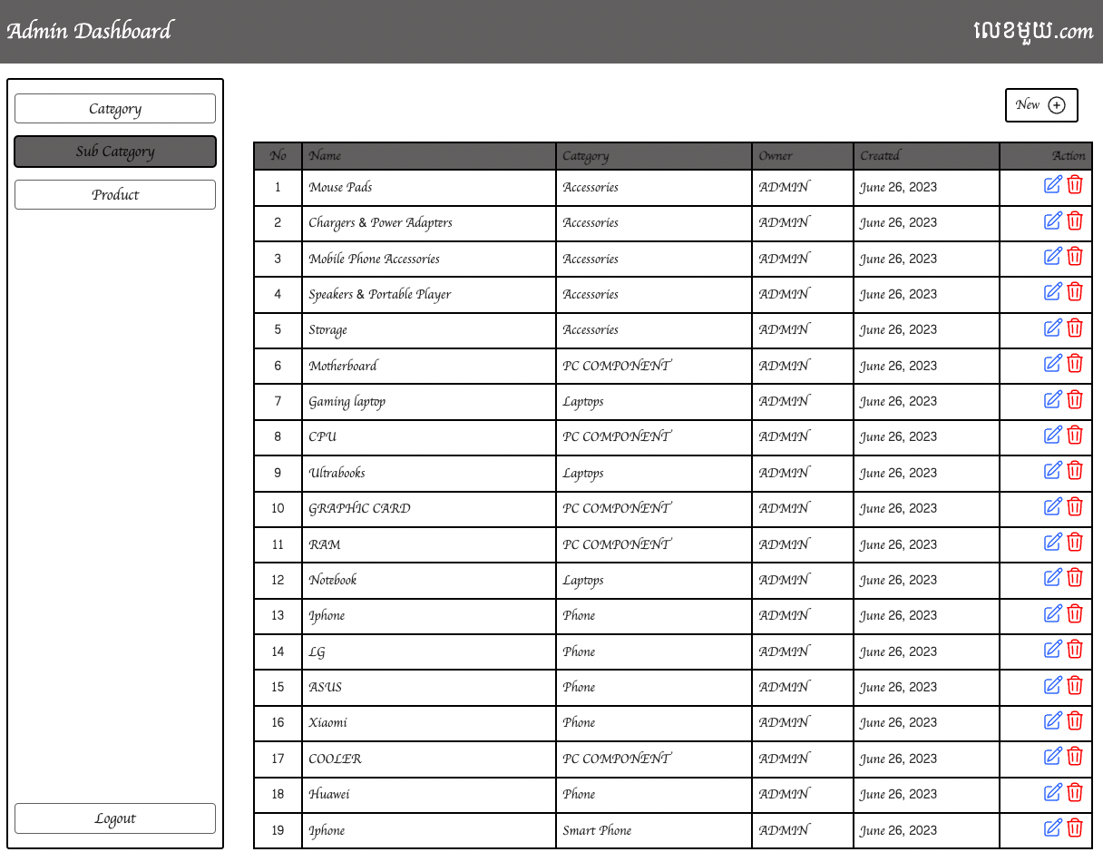

# Product

## Create New Product

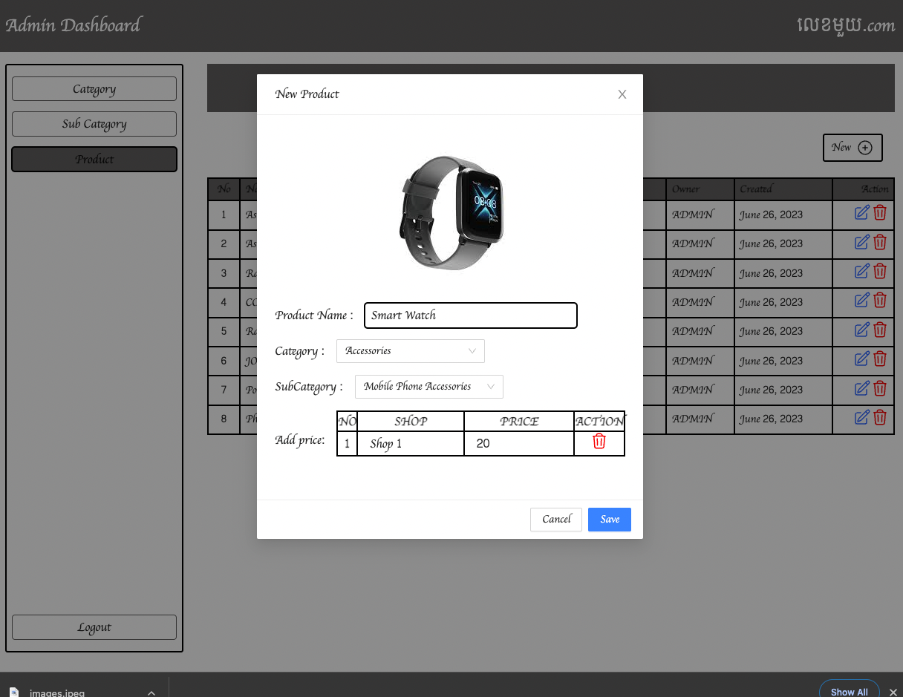

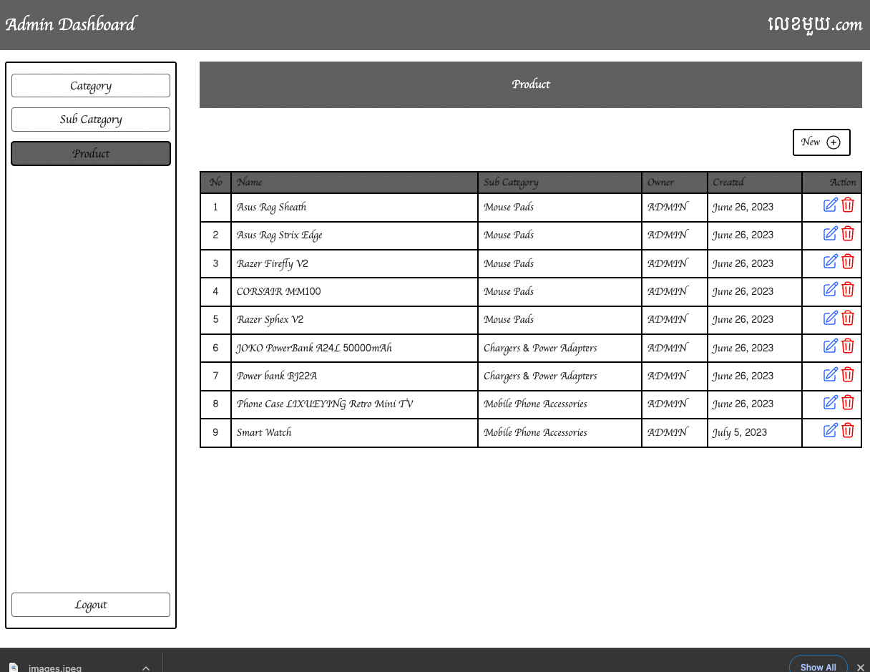

## Click Product to view product detail

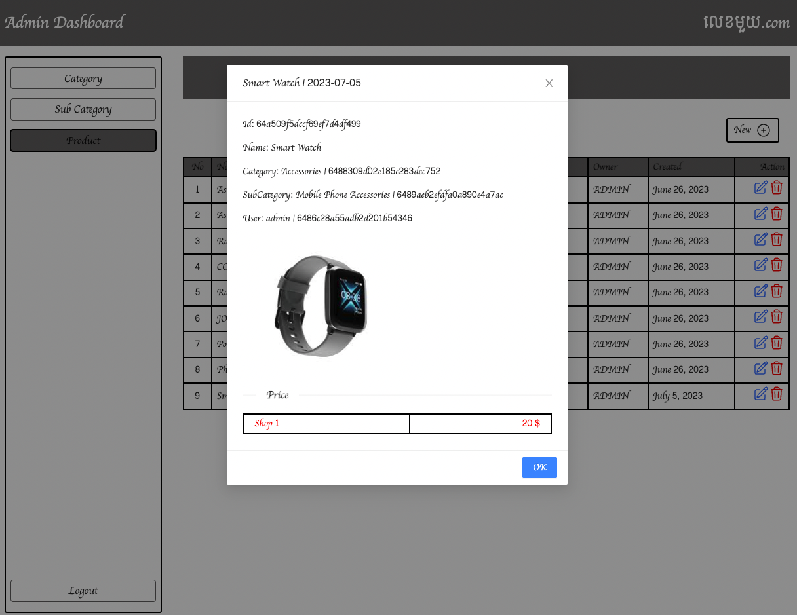

-Update Product

+Change Name and Add price

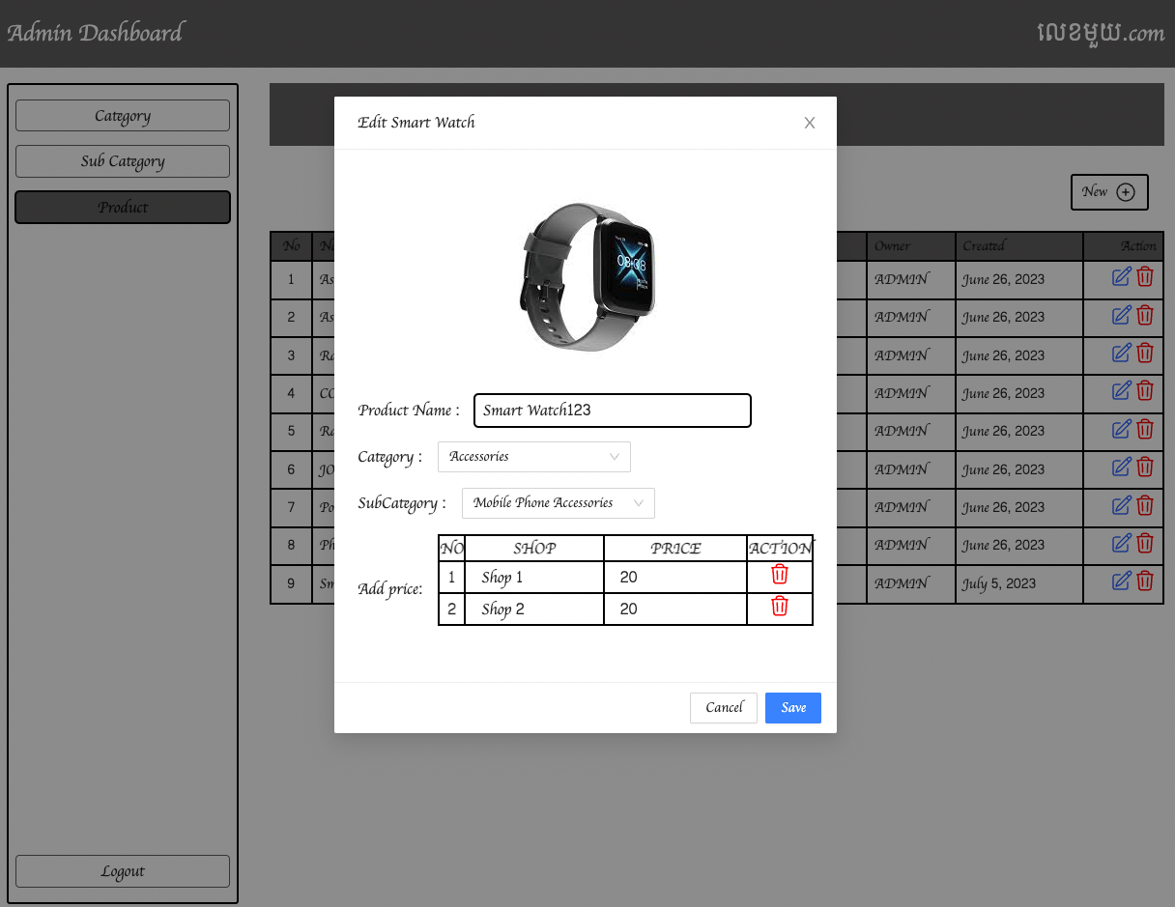

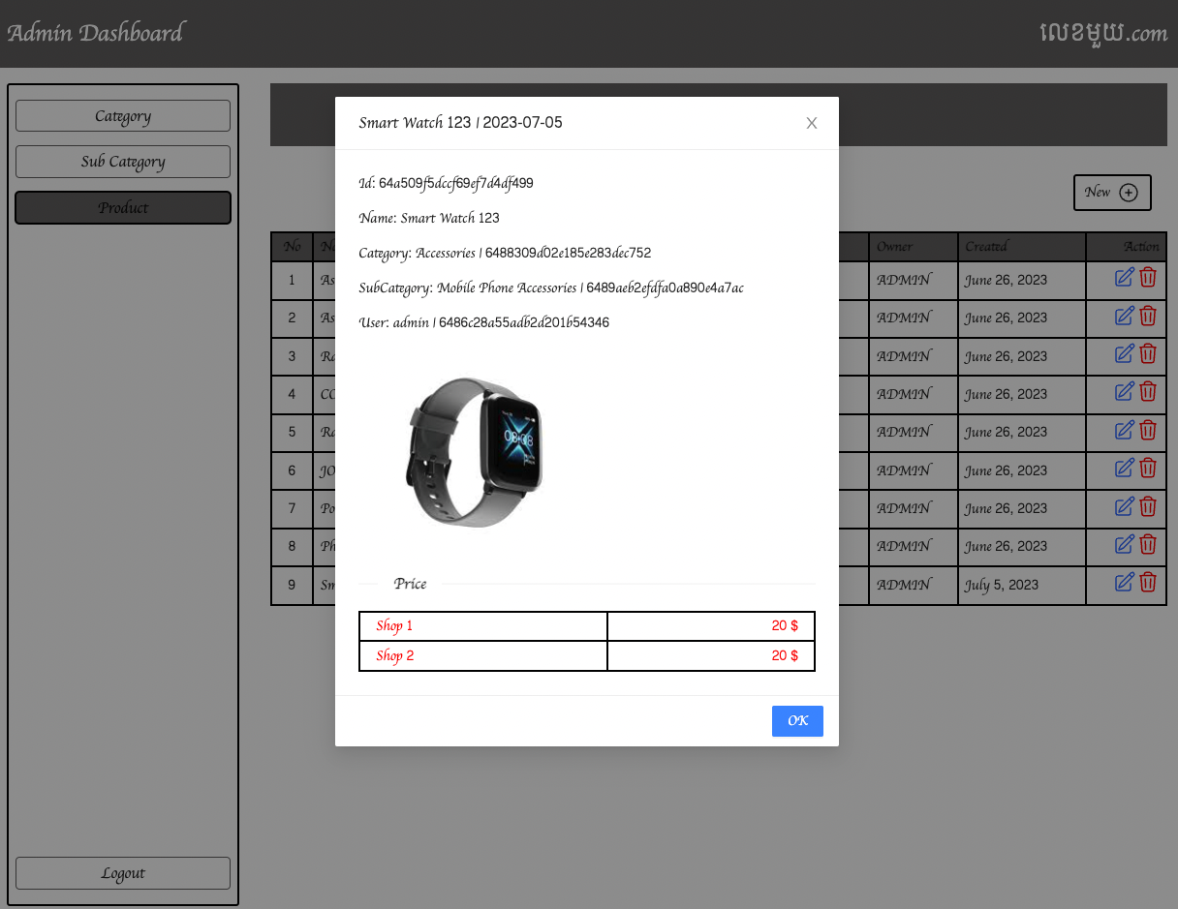

## Delete Product

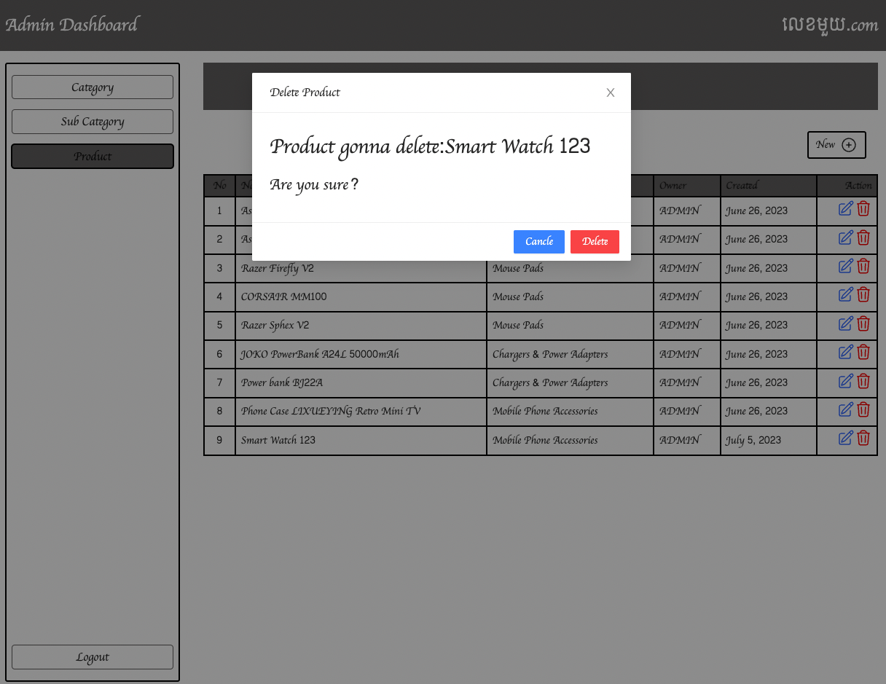

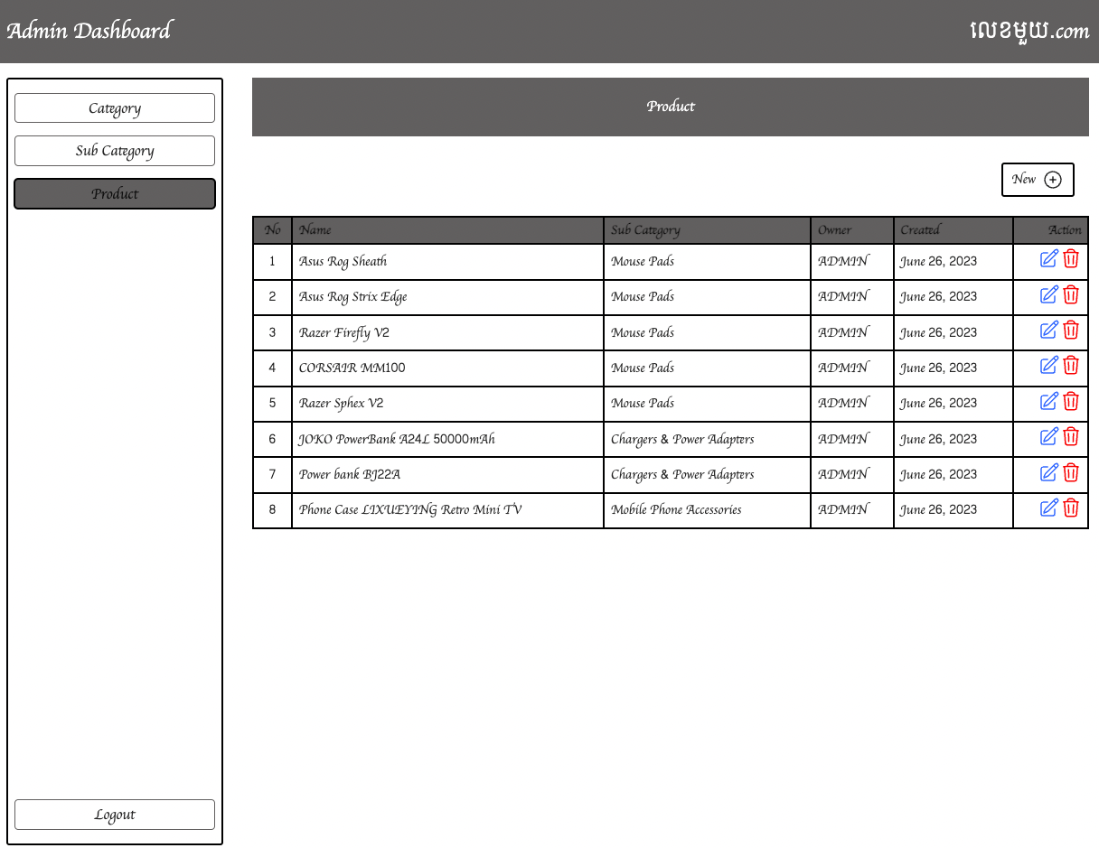

## Home view after do crud on category, subcategory and product

